Demographic Analysis of Technopreneurial Ventures Across Industries
Assessment of Market trends and Product Success Metrics
Section I: Educational Profile & Gender Distribution of Technopreneurs
Most of the surveyed technopreneurial ventures are spearheaded by male founders, highlighting an ongoing and profound structural gender gap within advanced technical entrepreneurship ecosystems.

This initial layer of analysis examines the demographic breakdown of 30 cross-industry technopreneurial ventures by the highest educational attainment of the founders against their gender identity. The objective is to identify baseline educational qualifications that serve as catalysts for high-tech entrepreneurship and map the extent of the prevailing gender disparity.

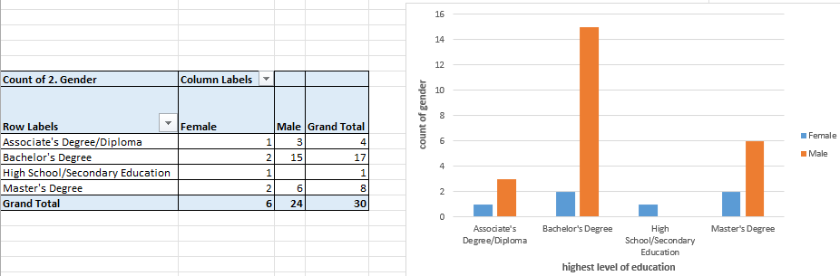The overall majority of responses provided in the demographic survey come from both male and female founders whose highest level of education is a Bachelor's degree.
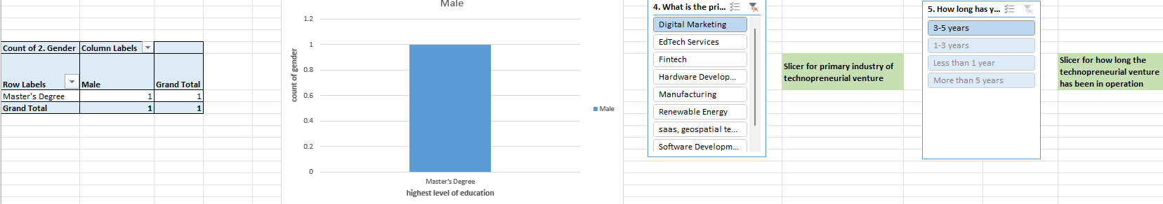
In the digital marketing industry cohort operating for 3–5 years, the data indicates that only a single male respondent who has attained a Master's degree provided a response.
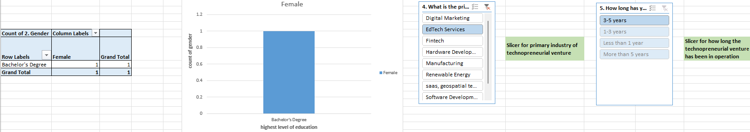
For EdTech Services operating for 3–5 years, the survey records a single female respondent whose highest level of education is a Bachelor's degree.
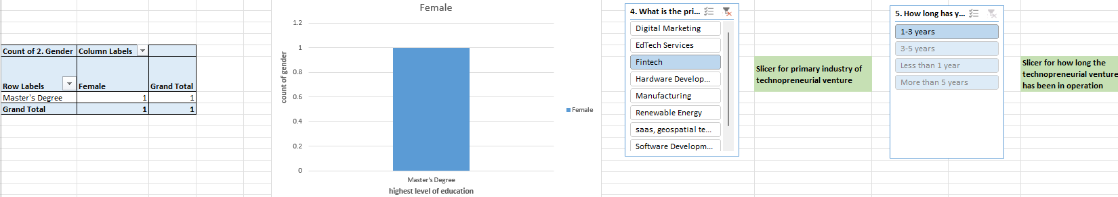
In the Fintech industry cohort operating for 1–3 years, there is a single female respondent who possesses a Master's degree as her highest level of education.
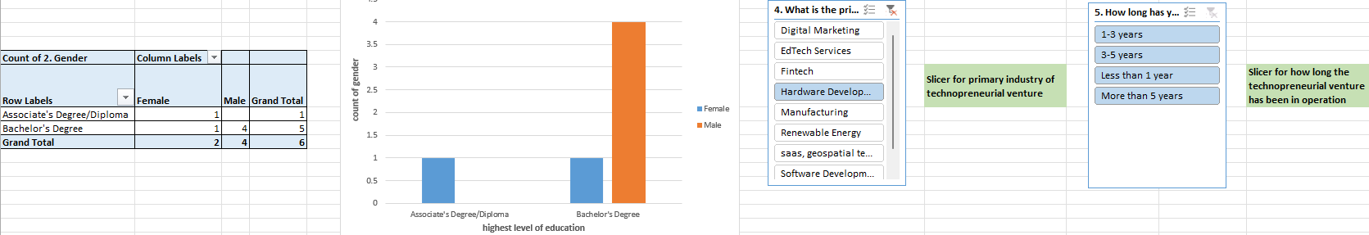
From the Hardware Development sector, the respondents include Bachelor's degree holders (comprising 4 male respondents and 1 female respondent) as well as an Associate Degree/Diploma holder (1 female respondent) contributing their data to this demographic analysis.
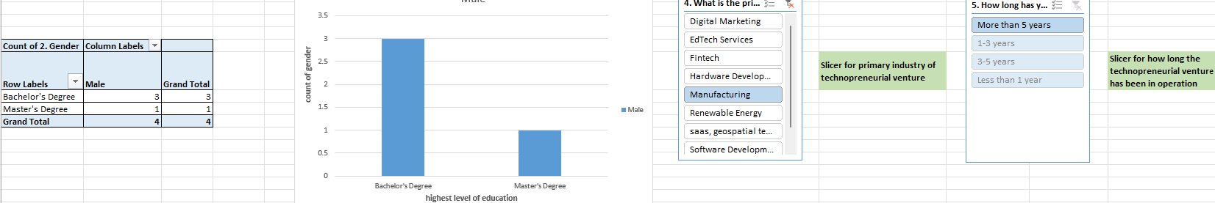
In the field of manufacturing, the respondent pool consists exclusively of male founders holding either a Bachelor's or a Master's degree.
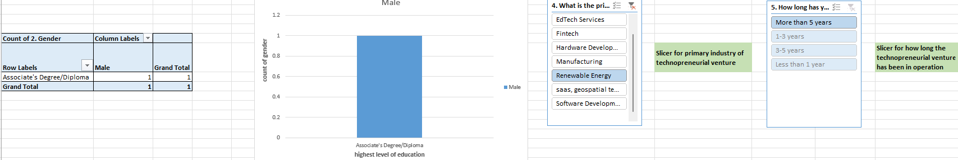
The data indicates that within the renewable energy sector, the sole respondent is a male founder holding an Associate Degree/Diploma.

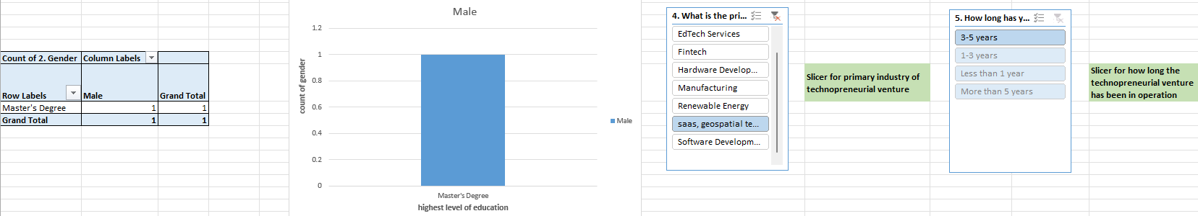
From the SaaS and geospatial technology sector, there is a single male respondent who has achieved a Master's degree as his highest level of education.
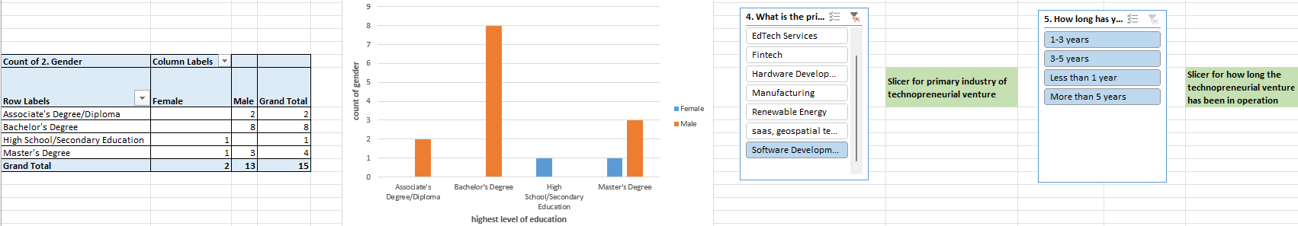
Within the Software Development sector, respondents are distributed across all educational degree tiers, including a significant concentration of 8 respondents who have attained a Bachelor's degree.

Key Insights
- Bachelor’s Degrees as the Dominant Entry Point: Out of the 30 ventures assessed, a commanding majority of 17 are led by founders whose highest level of qualification is a Bachelor's Degree. This indicates that while advanced scientific specialization is valuable, technical or commercial grounding provides sufficient baseline to launch tech-focused firms.
- High Post-Graduate Penetration: Founders holding Master's Degrees represent the second-largest cohort, accounting for 8 ventures. When aggregated with Bachelor's degrees, approximately 83.4% of the technopreneurial ecosystem is governed by individuals possessing standard or advanced university degrees, underscoring the correlation between academic access and industrial tech creation.
- The Gender Asymmetry: The demographics shows that: 24 ventures are male-led, while only 6 are female-led. This imbalance runs across nearly all educational tiers especially at Bachelor's level, which features 15 males compared to just 2 females.
- Sub-Sector Educational Alignment: When filtering by industry, Software Development emerges as important for academic density, absorbing a majority of the Bachelor's and Master's cohorts. In contrast, capital-intensive segments like Renewable Energy or Hardware Development present highly fragmented, low-sample profiles that are primarily male-dominated.

Section II: Pricing Architecture & Competitive Market Hurdles
Managing levels of pricing and structuring dynamic strategy scores the highest overall institutional friction rating, outranking direct market competition as a threat vector.

This matrix shifts focus to operational viability, compiling the average pressure ratings of various commercial, and regulatory risk factors on a scale of 1 to 5. It maps out exactly where technopreneurs experience intense internal friction versus external market constraints.
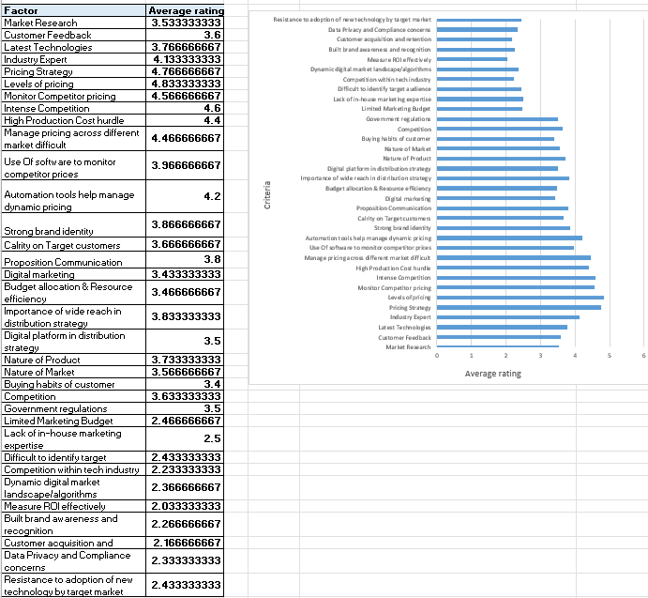

Key Insights
- The Pricing Sovereignty Crisis: The data isolates pricing variables as the single most punishing operational cluster. 'Levels of pricing' leads all criteria with an extraordinary average difficulty rating of 4.83, closely followed by 'Pricing Strategy' at 4.76, 'Monitor Competitor pricing' at 4.56, and 'Manage pricing across different markets' at 4.46. This proves that long-term fiscal engineering, margin maintenance, and price discovery are vastly more problematic for tech ventures than building the product itself.
- Intense Competitor Landscape: External structural competition matches this internal friction, securing a high 4.60 score. Combined with 'High Production Cost hurdles' at 4.40, it is evident that raw input costs are elevated, yet competitor market environments severely restrict the capacity to pass costs onto clients.
- Marketing Infrastructure Under-Sizing: Baseline promotional factors like 'Limited Marketing Budget' are rated 2.46, and 'Lack of in-house marketing expertise' sits at 2.50. This reveals that tech founders do not perceive marketing reach or capability as existential barriers.
- Lower Tier Frictions: Regulatory risks ('Government regulations' at 3.50) and consumer barriers ('Resistance to adoption of new technology' at 2.43) occupy a moderate-to-low positioning, indicating that slow consumer cycles are secondary to immediate pricing.
Interpretation
The massive disparity between high pricing stress (4.83) and low marketing-budget (2.46) exposes a common trap for technical founders. Technopreneurs are overconfident in their lean product visibility but possess dangerously weak price architecture models. Because they operate in crowded, price-transparent spaces, they lack the data tools to institute real-time, value-based pricing.

Section III: Industrial Cluster Density & Core Sector Specialization
Software Development exerts an absolute monopoly over the technopreneurial landscape, accounting for (15 out of 30) of established ventures.

This indicates sector density map across the 30-firm sample. By analyzing this pie distribution, we can distinguish between major and minor tech sectors that may indicate systemic capital barriers or structural bottlenecks.
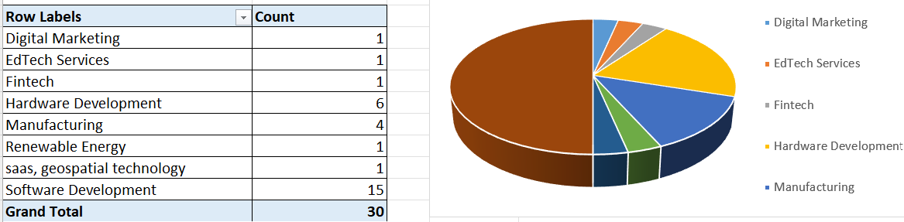

Key Insights
- Software Dominance: With 15 ventures explicitly focused on Software Development, this single sector matches the volume of all other industries combined.
- Hardware and Manufacturing Infrastructure: Hardware Development captures 6 firms, and industrial Manufacturing claims 4 firms. Together, these account for one-third of the ecosystem. Their lower density compared to software directly reflects the challenges of supply chain setup, manufacturing, and hardware development lifecycles.
- Niche and Emerging Spaces: The remaining sectors: Digital Marketing (1), EdTech Services (1), Fintech (1), Renewable Energy (1), and SaaS/Geospatial Technology (1) account for about 3.3% each. This implies that specialized software are not scaling at an organic pace within this ecosystem.
Interpretation
The concentration of ventures in Software Development suggests a skewed entrepreneurial ecosystem. The trace representation in Renewable Energy, Fintech, and Geospatial systems reflects an ecosystem failing to bridge the gap in physical-layer infrastructure.

Section IV: Product Development Paradigms
Customer-Centricity approach for product development acts as foundation across all operational ages, but early-stage ventures (under 1 year) display highly fragmented framework comprehension.

This matrix provides an insightful look into product management methodologies.

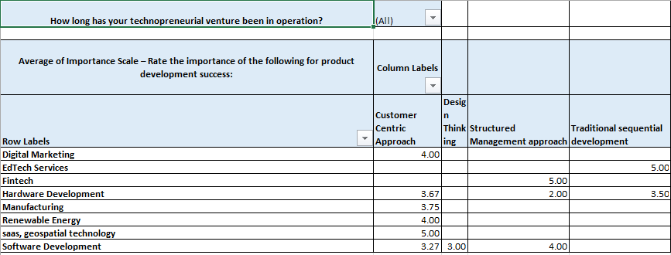

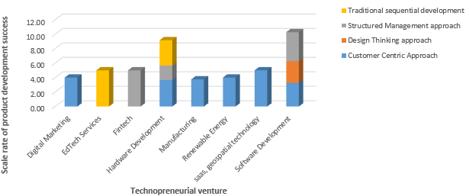
From the chart and table analysis, we observe the following operational patterns:
- Software Development: This sector consistently balances a customer-centric focus and design thinking with a major reliance on structured management approaches (scoring a high 4.00) to ensure successful, repeatable product delivery to customers.
- Hardware Development: This vertical prioritizes customer-centric discovery (averaging 3.67) but maintains a balanced mix of structured project management and traditional sequential (Waterfall) development to manage fixed physical tooling risks.
- Emerging Verticals: Digital Marketing, Manufacturing, SaaS, and Renewable Energy focus almost exclusively on continuous user feedback loops to meet requirements. Conversely, EdTech services rely heavily on traditional sequential development, and Fintech operates strictly through formalized, structured management frameworks.
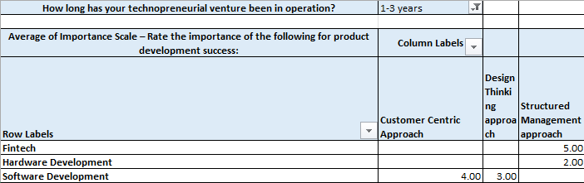
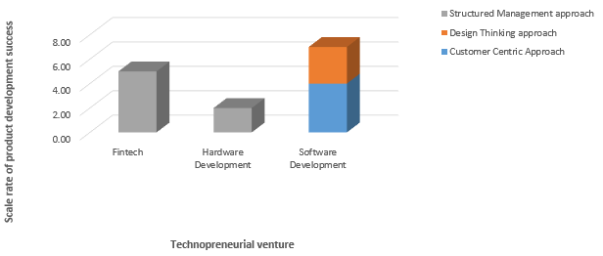

For firms operating in the 1–3 year window, tech industries such as Fintech and Hardware focus heavily on structured management, while Software relies on a blend of customer-centric and design-thinking approaches to develop products.

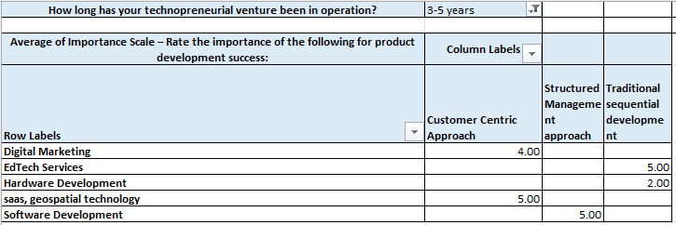
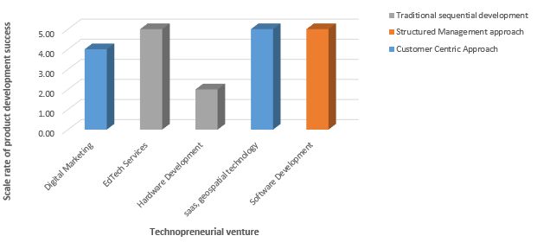

For mid-stage firms (3–5 years in operation), sectors like Hardware and EdTech Services integrate traditional sequential development models to stabilize product iteration. Conversely, Software Development shifts its focus toward structured management frameworks, while Digital Marketing and SaaS maintain an agile, customer-centric approach.

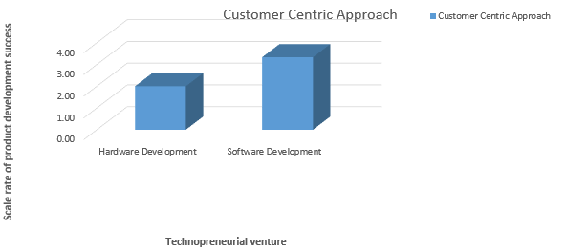
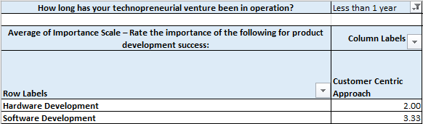

In the initial stages hardware and software rightly focused on only customer centric approach.
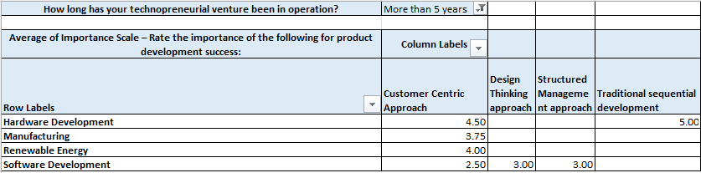
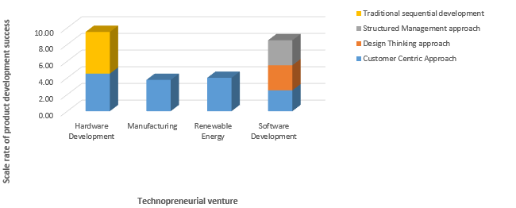

With more than 5 years of Industry In operation it shows that hardware relies more on sequential development rather than just being customer centric.

Key Insights
- Early-Stage (<1 Year): Startups operating in their first year demonstrate an exclusive reliance on a single framework. The data records a 2.00 rating for Hardware and a 3.33 rating for Software purely focused on the Customer Centric Approach, with absolute zeroes across Structured Management or Design Thinking.
- Mid-Stage (1–3 Years & 3–5 Years): Here Software Development indicates an average of 4.00 alongside Customer Centricity approach. Concurrently, sectors like Design Thinking by applying Customer Centric approach provides an average response of 3.00.
- Long-Term (>5 Years): In Hardware, a 5.00 average score for sequential development, complemented by 4.50 for Customer Centricity. This reflects a calculated return to fixed, predictable product roadmaps necessitated by large-scale production cycles.
- Verticals: SaaS and Geospatial firms operating in the 3–5 year report an absolute commitment to Customer Centric approaches, demonstrating that cloud-native businesses rely completely on continuous feedback loops to limit user churn.
Interpretation
The total absence of Structured Management or Design Thinking methodologies in early-stage ventures under 1 year reveals a severe structural vulnerability. Startups are failing to build product framework discipline early, creating a dangerous operational cliff as they expand. When these teams experience rapid growth, their lack of structured product architecture leads to massive operational friction, internal misalignment, and high technical debt.

Section V: Pricing Strategy Update Frequency
Early-stage firms (<1 year) exhibit highly rigid pricing behaviors, updating strategies only annually, whereas mature entities establish rigorous, market-driven dynamic schedules.

This segment examines the correlation between a operation and the frequency with which it re-evaluates its pricing strategies. It maps out whether operational maturity directly correlates with a team's willingness to execute agile, data-driven pricing revisions.
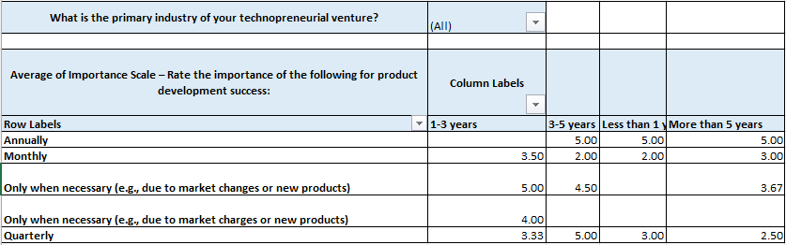
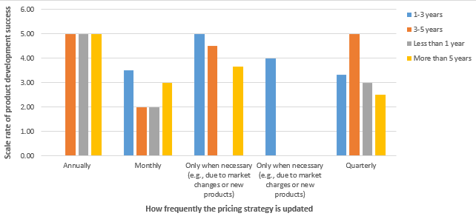
In a duration of 3-5 years, less than a year, or more than 5 years the pricing strategy overall across all sectors are updated annually. Also when necessary the product prices are updated based on the market changes, charges, or launch of any new product.

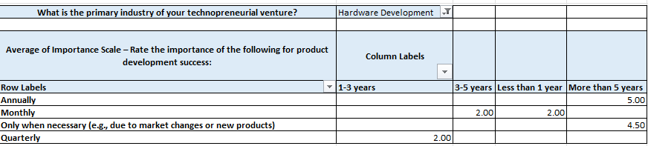

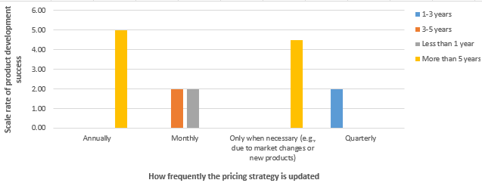

In the hardware development sector the product prices are updated annually or only when necessary.

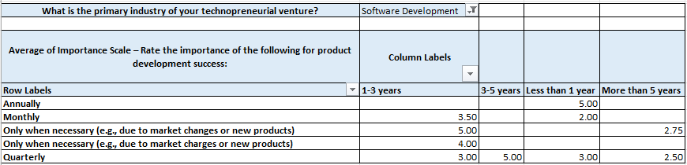
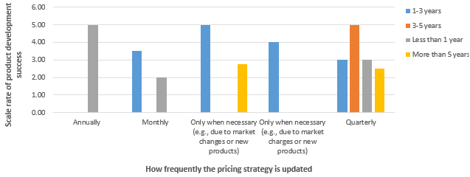
In software sector in initial stages of the startup they prefered updating their product prices annually, In about more than 5 years this sector prefered keeping the prices more stable and update only when necessary or quarterly.

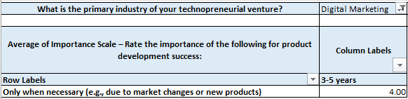
In digital marketing in 3-5 years product prices are updated.

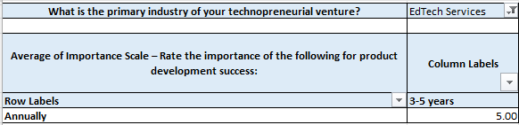
In EdTech Services prices on products are updated annually.
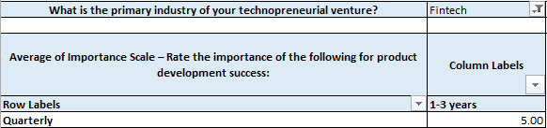
Fintech ventures show high agility, choosing to evaluate and update their pricing structures quarterly.
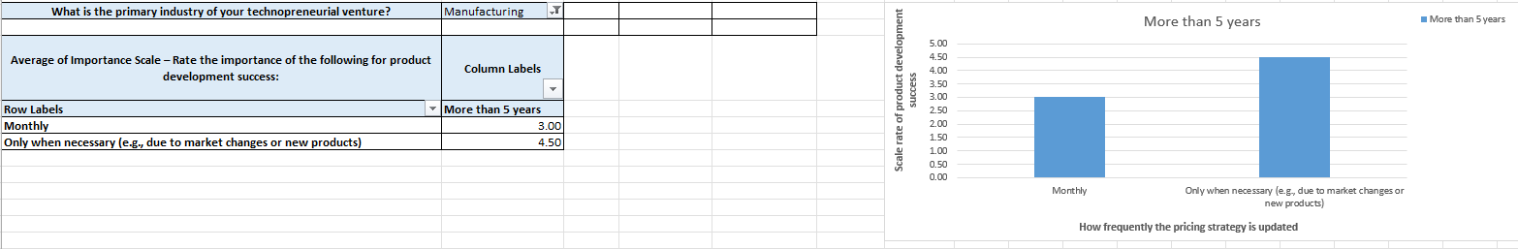
The Industrial Manufacturing sector updates its prices either in direct response to raw market material variations or on a tight monthly schedule to preserve margins.

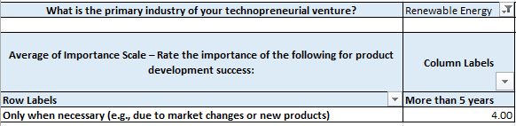

The Renewable Energy sector keeps its pricing exceptionally stable, executing updates only after a duration of 5 years, and then only if major structural changes are observed in market trends.

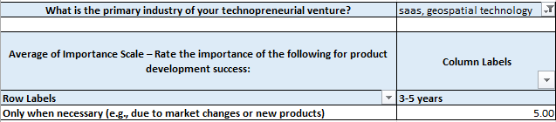

SaaS and geospatial technology ventures update their product prices only when facing direct, unavoidable market variations.

Key Insights
- The Early-Stage: Startups operating for less than 1 year report an importance score of 5.00 for 'Annually' updated pricing strategies, with a massive drop-off for higher frequencies.
- The Mid-Stage (1–3 Years): Ventures in the critical 1–3 year growth window show a strong migration toward responsiveness. This cohort rates 'Only when necessary (e.g., due to market changes or new products)' at a peak importance score of 5.00. This indicates an adaptive phase where firms actively adjust their pricing structures in response to competitive threats or immediate macroeconomic shifts.
- Software vs. Hardware: Software Development exhibits the broadest operational spread, scoring 5.00 for quarterly adjustments in the 3–5 year bracket. Conversely, Hardware Development remains highly bound to structural timelines, rating annual reviews at 5.00.
- Trace Sector Isolation: Fintech and EdTech services show highly compressed update schedules, preferring strict quarterly or annual cycles respectively.
Interpretation
The data clearly shows that as technopreneurs gain operational maturity, they realize static pricing models are unsustainable in volatile markets. Early-stage firms' reliance on rigid annual updates makes them highly vulnerable to sudden competitor promotions or price adjustments. To protect profit margins and drive revenue growth, early-stage ventures must build dynamic, automated pricing mechanisms into their platforms. By actively tracking real-time market shifts and customer demand profiles, startups can avoid under-pricing their offerings and capturing less value than they deserve.

Section VI: Technological Upgrade Frequency & Strategic Growth Pathways
'Product Improvement' represents the dominant growth pathway, capturing (19 out of 30) of all cross-industry tech venture strategic updates.

This section provides insights of how technopreneurs execute technical upgrades on their core products, categorizing their growth focus into Diversification, Market Expansion, Product Improvement, or Product Line Extension. This helps distinguish between risk-averse iterative optimization and aggressive, expansion-oriented strategies.
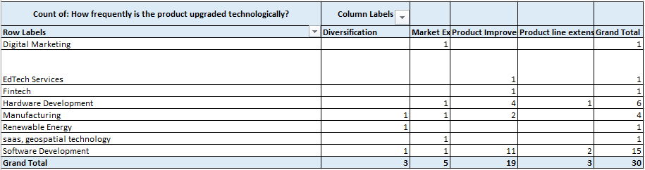
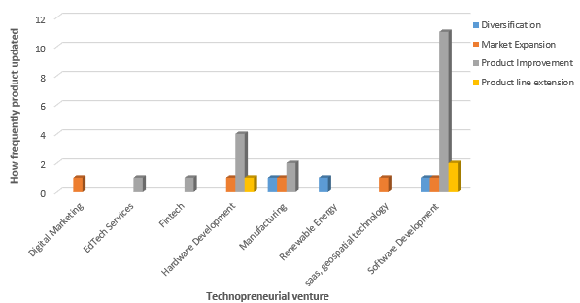
From the table/legend that is shown above Diversification, Market Expansion, Product Improvement, Product line extension represents the product development strategy followed by the sectors, and numeric values in the table represents how frequently the product is upgrated technologically in each sector. Among all sectors Software development sector applies Product improvement for product development strategy to improve their product demand. Other sectors like Digital marketing follows market expansion strategy, and renewable energy sector follows diversification strategy.
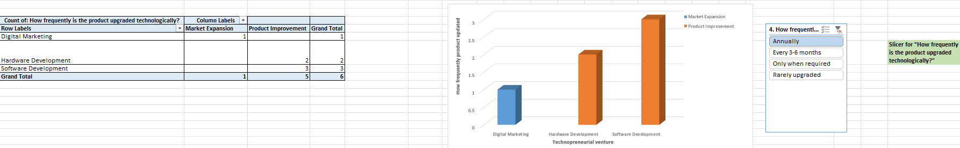
Annually the product is upgrated by software and hardware sectors using product improvement approach and digital marketing sector annually upgrates product following market expansion criteria.
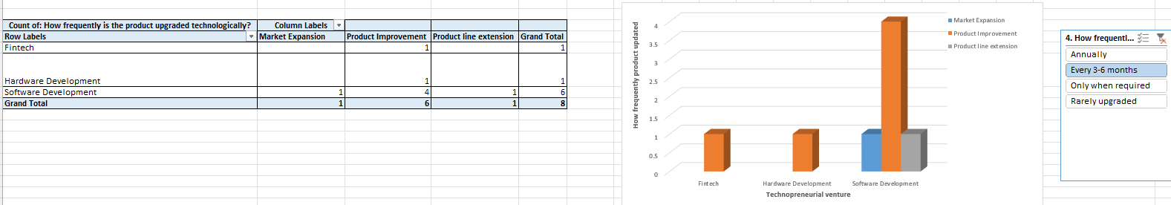
Every 3-6 months it is seen that software industries apart from product improvement they also concentrate on approaches such as market expansion (expanding market to new geographic regions to target new customers), and product line extension strategy (to launch new variations of existing product within the same category) to reach new audience and increase revenue.
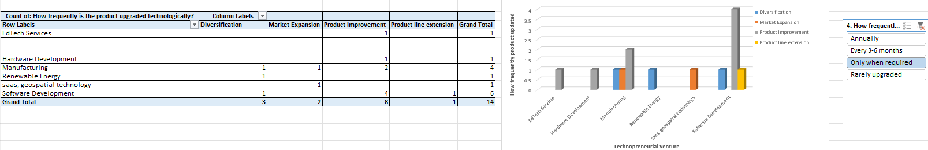
All sectors except Fintech and digital marketing upgrates product development strategy based on the market variations.

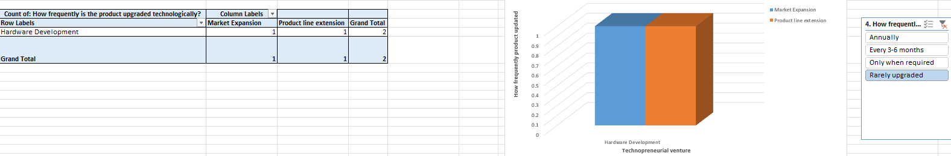
Only in the hardware sector the product prices are rarely upgrated in market expansion and product line extension strategies.

Key Insights
- The Product Improvement: Most firms prioritize iterative 'Product Improvement' over all other growth strategies. Software Development leads this trend, dedicating 11 of its 15 ventures entirely to refining existing features, where teams focus on optimizing a single core offering rather than branching into new segments.
- Stagnation of Diversification: True strategic diversification is rare, appearing in only 3 out of 30 ventures. These instances are limited to Manufacturing (1), Renewable Energy (1), and Software (1). This confirms that tech companies find it highly difficult to enter new market by developing entirely new product.
- Market Expansion Truncation: Market Expansion captures 5 ventures, showing a balanced distribution across Digital Marketing, Hardware, Manufacturing, SaaS, and Software. This indicates a steady but modest effort to scale products geographically.
- Product Line Extensions: Product Line Extensions are minimally represented with only 3 ventures (2 in Software, 1 in Hardware), further illustrating a widespread preference for a single product focus over multi-tiered product portfolios.
Interpretation
The intense reliance on simple, iterative 'Product Improvement' reveals a broader trend of strategic caution within the tech sector. While continuous updates are crucial for maintaining user engagement, feature optimization can trap ventures in localized performance loops, leaving them blind to larger market disruptions. This trend often stems from limited growth capital or an inability to accurately evaluate new markets.

Section VII: Demographics including highest level of degree
Startups led by founders aged 55+ account for a (13 out of 30) of the total enterprise ecosystem.

This matrix cross-tabulates founder age and gender profile metrics against their perceived marketing and financial resource constraints. It clarifies exactly how capital limitations and operational scaling pressures impact different demographic groups within the tech venture ecosystem.
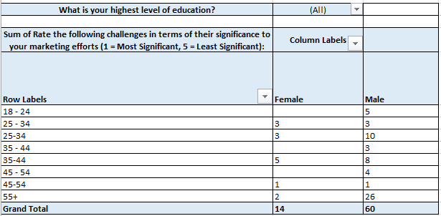
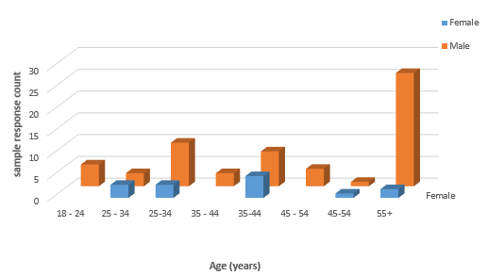
Across all combined sectors, a significant baseline trend emerges: the ecosystem features a much larger volume of male respondents compared to female respondents across nearly all age brackets.

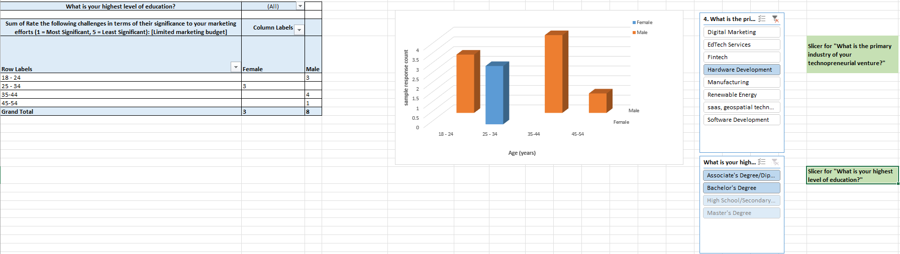

In the Hardware Development sector, the demographic profile shows 3 female respondents concentrated in the young 25–34 age bracket, contrasted against 8 male respondents distributed across various age groups holding Associate or Bachelor's degrees.

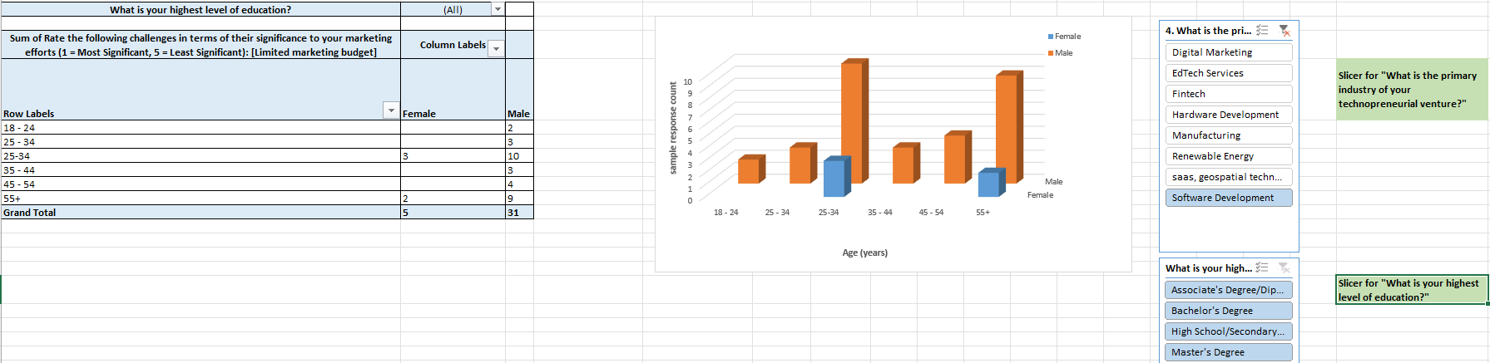
In the Software Development sector, the distribution confirms that male founders occupy the vast majority of enterprise leadership and founder positions compared to female counterparts.

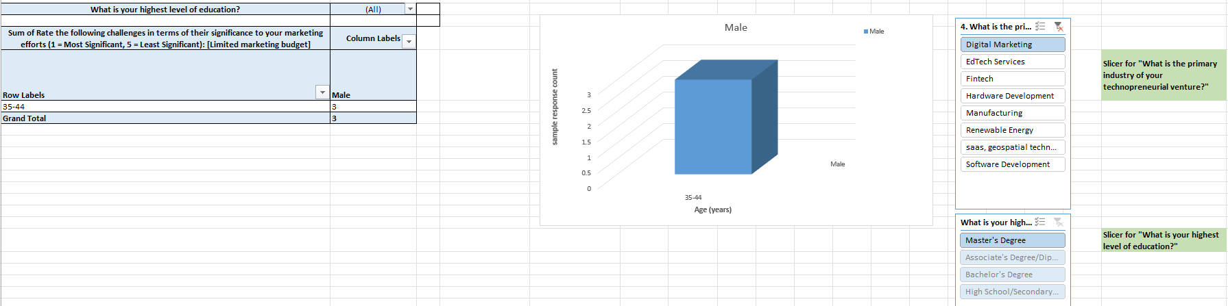The Digital Marketing sector is entirely dominated by middle-aged male entrepreneurs concentrated in the 35–44 age bracket.

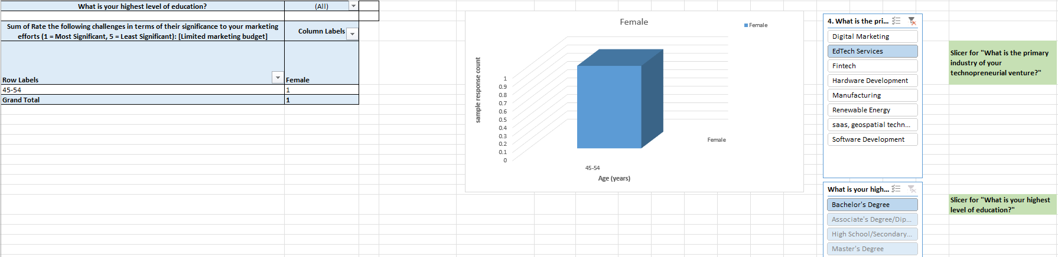The survey records a single female respondent between the ages of 45–54 representing EdTech Services, with a Bachelor's degree marked as her highest academic qualification.

From the Fintech domain, the data shows an isolated cluster of 5 female respondents aged 35–44, all of whom hold a Master’s degree as their highest level of education.

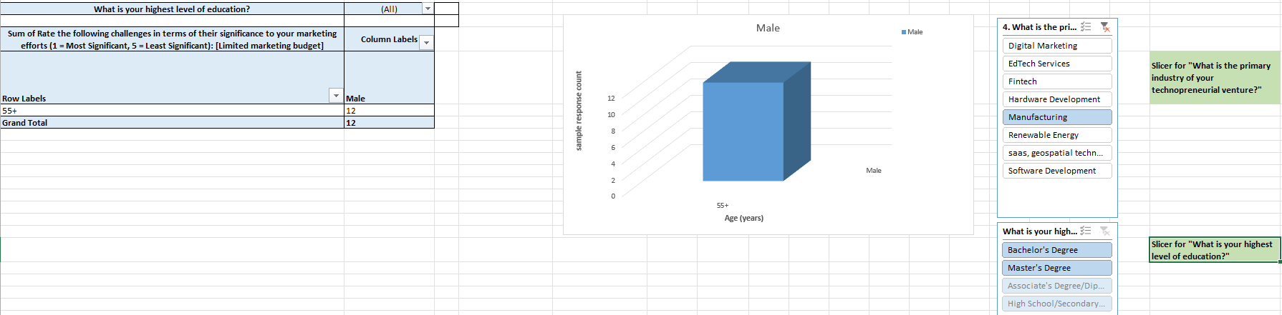

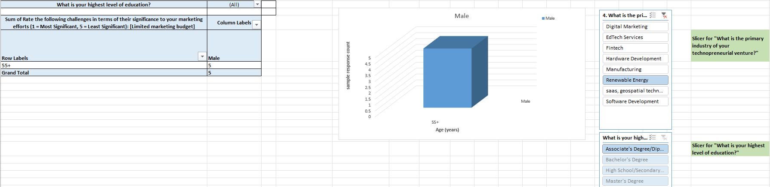

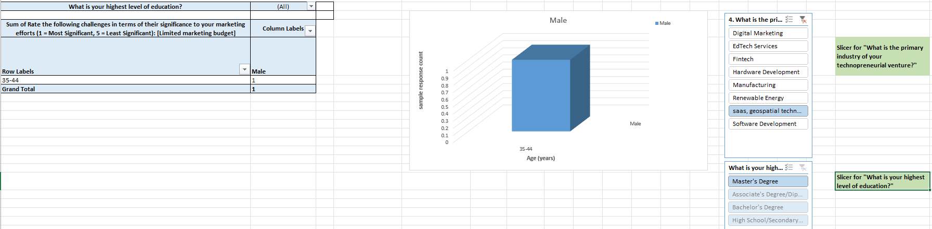
Industrial Manufacturing, Renewable Energy, and SaaS/Geospatial Technology confirms that these three sectors are led exclusively by male respondents.

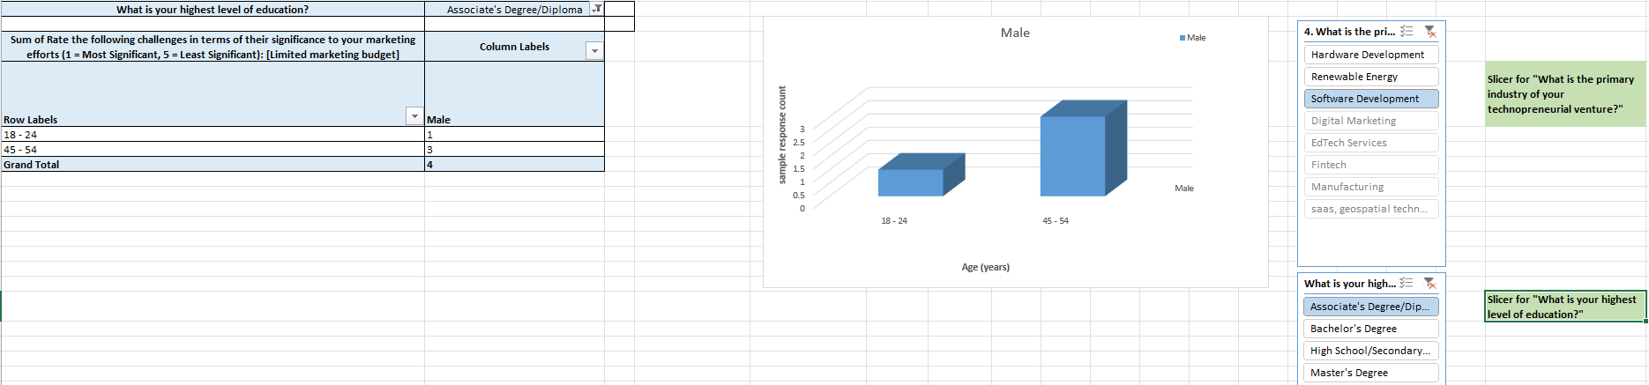
Software Development specifically for applied technical degrees, the survey captures an equal distribution of both male and female respondents holding Associate Degrees or Diplomas.

Key Insight
- Demographic Monopoly: The absolute numbers shows unexpected concentration: out of 30 ventures, 13 are anchored by male founders aged 55 or older. This challenges the common startup narrative that the tech sector is exclusively driven by very young entrepreneurs. Instead, it highlights the critical role that deep industry experience, mature professional networks, and personal capital play in launching tech firms.

Section VIII: Data Analytics Penetration & Customer Co-Creation Integration
Most tech ventures have fully integrated customer feedback loop architectures into their workflows, yet data analytics infrastructure remains heavily under-utilized.

This section focuses on internal data maturity, analyzing how consistently firms leverage formal data analytics platforms and customer co-creation mechanisms to guide their product decisions. This highlights the gap between qualitative customer conversations and rigorous, data-driven quantitative analysis.
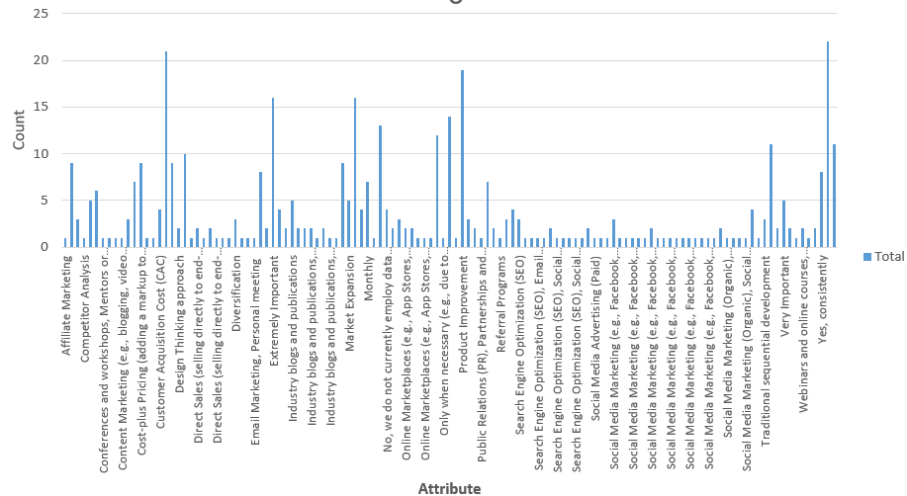
The above shows the distribution of responses for questions asked. Here we see that there are more responses on ‘yes, occasionally’ with a count of 22, which are responses to questions: ‘Do you employee customers or users in product development process?’, and ‘Do you involve data analytics to refine digital marketing campaigns?’, ‘customer centric approach’ (count of responses agreeing to this condition is 21) ,including sections on ‘product improvement’ (count of agreed responses is 19), ‘market research’ (count of responses is 16),and ‘How important is website optimization for user experience (UX) and conversion rates in your digital marketing strategy?’ (count of responses is 16). So in this section we will explore these major areas that according to the survey data shows has a more impact across industries.

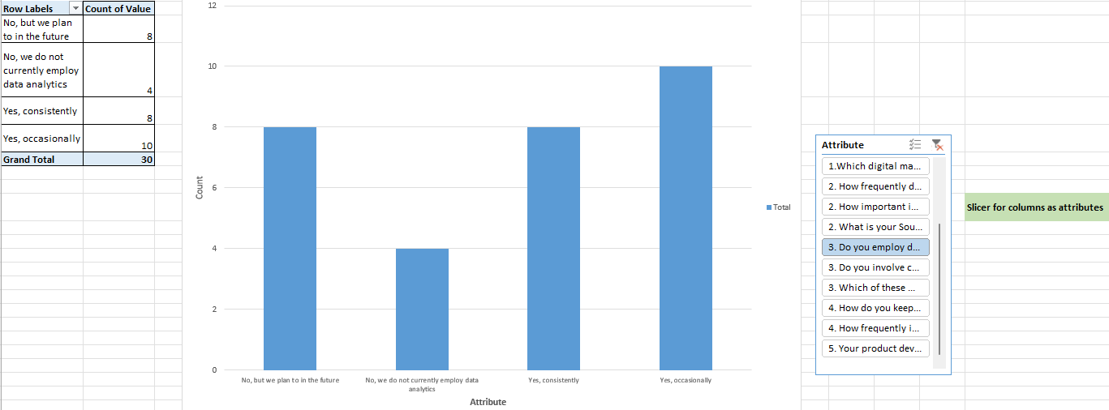
The above representation shows that all sectors occasionally employ data analytics and insights to refine digital marketing campaigns with a count of 10 positive responses.

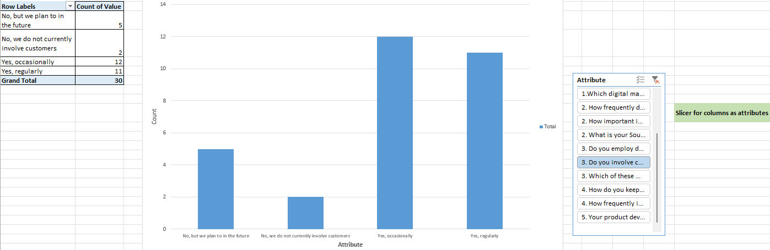
The plot shows that with a count of 12 responses across industries involves customers/users in their product development process.
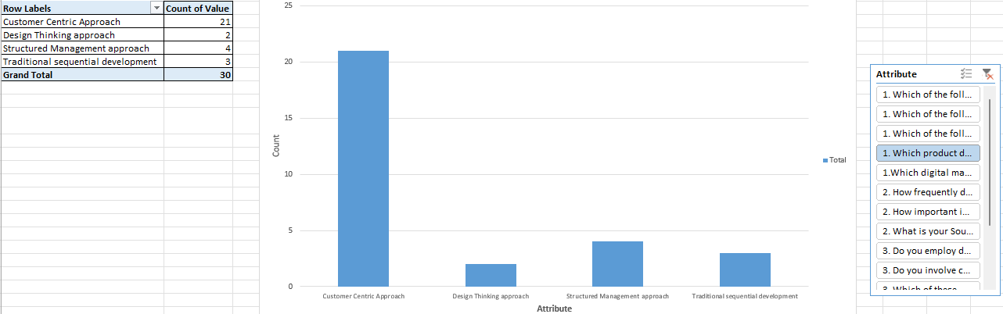
As seen in the above plot 20 responses across ventures agree that customer centric approach for successful product development is a preferred strategy.

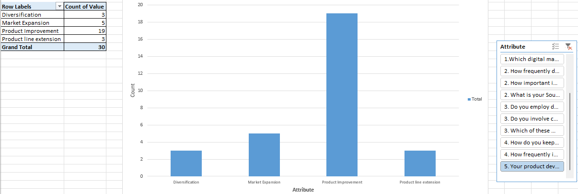
It is seen in the above bar chart that most sectors suggest that their product development strategy mainly focuses on Improving their existing product with about 19 agreed responses, followed by 5 responses suggesting that Market expansion could be a better approach that involves selling the existing products to new customer segments, demographics. About 3 responses suggests Diversification (developing entirely new product for new market) and Product line extension (adding slight variation/change in feature to the existing product line) is a suggested.

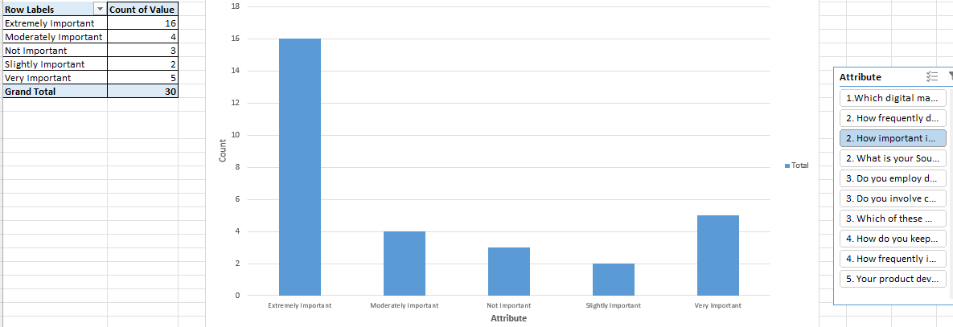
The visual shows that about 16 responses from the survey suggests that it is extremely important to optimize the website to enhance user experience (UX) and conversion rates in digital marketing strategy, this helps avoid spending more money on new visitors but instead generate more revenue from already existing audience.
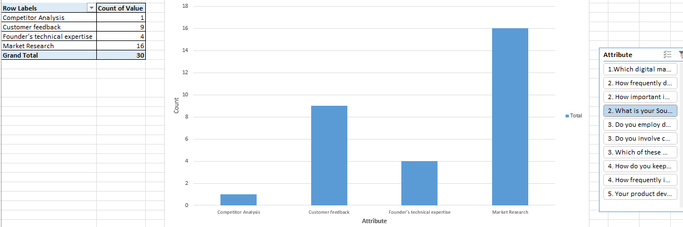
About 16 responses suggests that their main source of product ideas is obtained through market research that involves consumer related data obtained from surveys, focus groups, and competitor analysis.

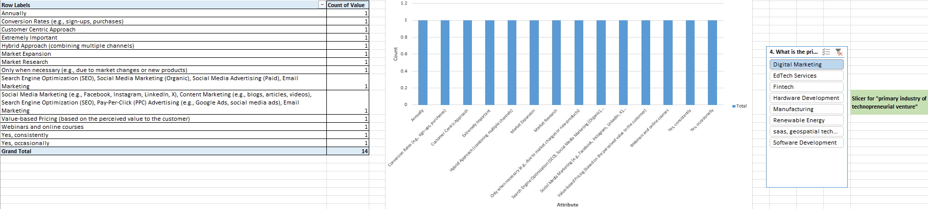
The responses suggests that in Digital market sector the product is updated annually, it focuses on conversion rates,customer centric approach, this sector focuses on the importance of UX optimization, Market expansion and research, search engine optimization, social media marketing, content marketing strategies to improve their business outcomes.

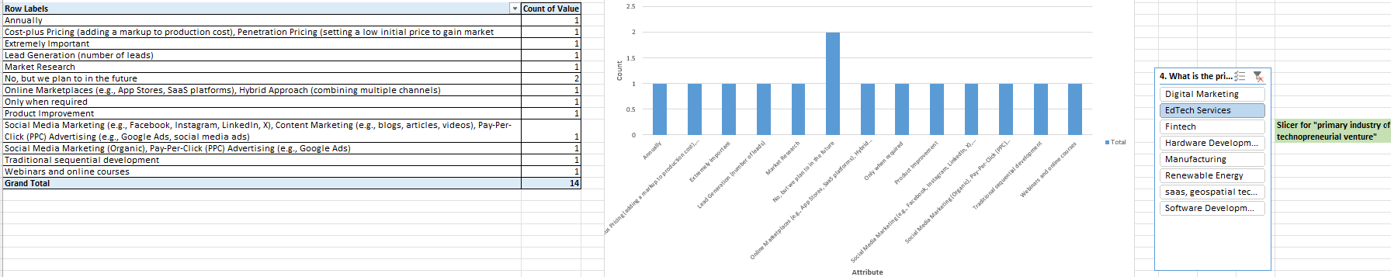The EdTech sector focuses on cost-plus pricing strategy to determine a suitable profit margin for customers, penetration pricing approach to set a suitably low initial product price, online market places, it provides highly effective educational marketing tools through webinar, online courses as services.

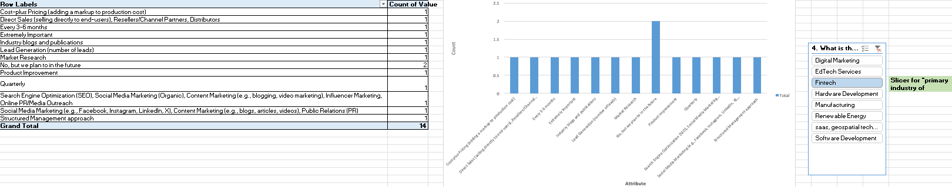
Fintech focuses on lead generation that involves offering free resource in exchange for contact details like email address etc, industry blogs and publication to stay ahead in rapidly evolving financial technology sector, Market research, social media marketing etc.
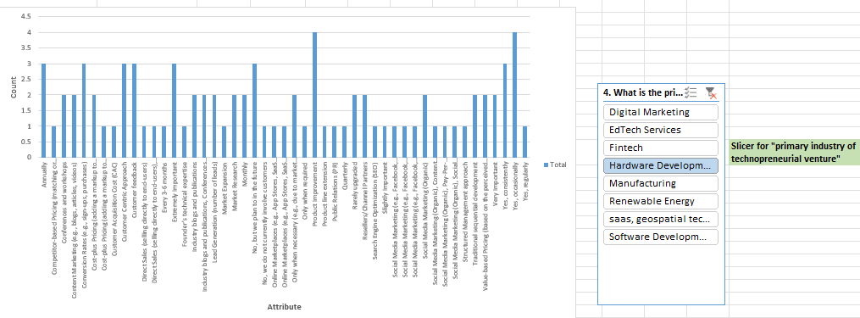
Responses from hardware venture shows that this sector focuses on conversion rate (optimizing how many website visitors turn into paying customers), content marketing (creating valuable material), conferences and workshops (to demonstrate their product), resellers/channel partners (using third party businesses to sell products on your behalf), etc.

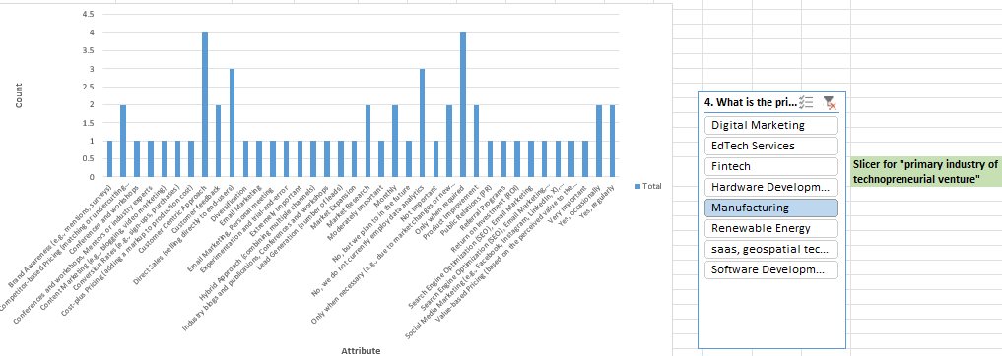As we see from the above factors Manufacturing sector prioritizes building widespread recognition and consumer trust through brand awarness, direct sales focus (this sector focuses to establish a direct relationship with customers), hybrid approach to maximize market penetration without relying on a single channel, etc.

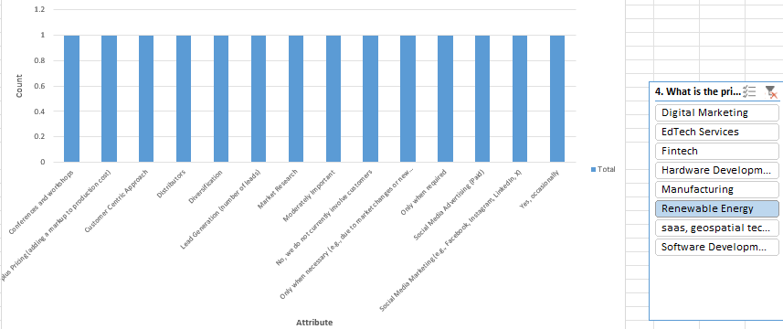
Renewable energy sector focuses more on diversifying their product, distributors, social media advertising, social media marketing etc.

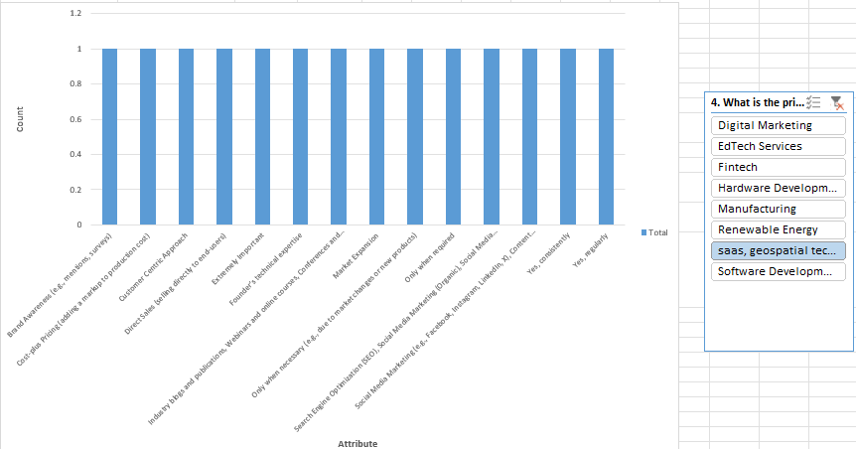
Saas and geospatial technology sector improvises their business by focusing on factors such as founders technical expertise, social media marketing, search engine optimization etc.

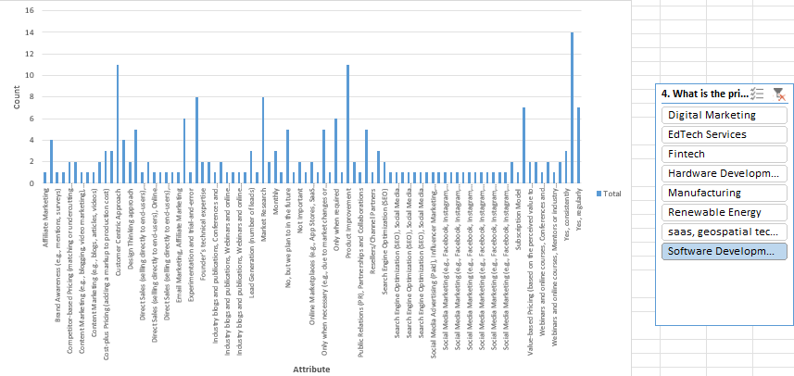

Software development industries improvises on most of the major factors including affiliate marketing (acquisition method/revenue sharing model), subscription model (monetization method), email marketing (to engage users and gather product feedback), partnership and collaboration and so on.

Key Insights
- Qualitative Integration: The data shows strong engagement with customer sentiment: 11 ventures report 'Yes, regularly' for customer involvement, and 12 report 'Yes, occasionally.'
- Quantitative Analytics Deficit: Very few ventures use modern data analytics tools while others do not use analytics at all.
- Industry Specific Variances: Software Development accounts for nearly all consistent users of data analytics, while asset-heavy verticals like Manufacturing and Hardware Development report no automated telemetry integration, relying instead on periodic survey data.
Interpretation
The significant gap between high customer consultation and low data analytics usage exposes a major operational weakness in early-stage tech firms. Relying too heavily on qualitative customer feedback can easily result in feature creep, where teams build custom, non-scalable solutions based on a few loud users. Without objective quantitative data to validate customer claims, tech founders risk over-engineering their products and driving up Customer Acquisition Costs.

Section IX: Cross-Industry Heatmap of Operational Risks & Performance Drivers
Industrial Manufacturing and Hardware Development show extreme risk profiles (scoring 1.00–1.83 across data privacy and tech resistance metrics), signaling a high chance of structural failure.

The final section provides a comprehensive cross-industry heatmap that scores operational risk variables and product success metrics on a 1.00 to 5.00 scale across all 8 major tech verticals.
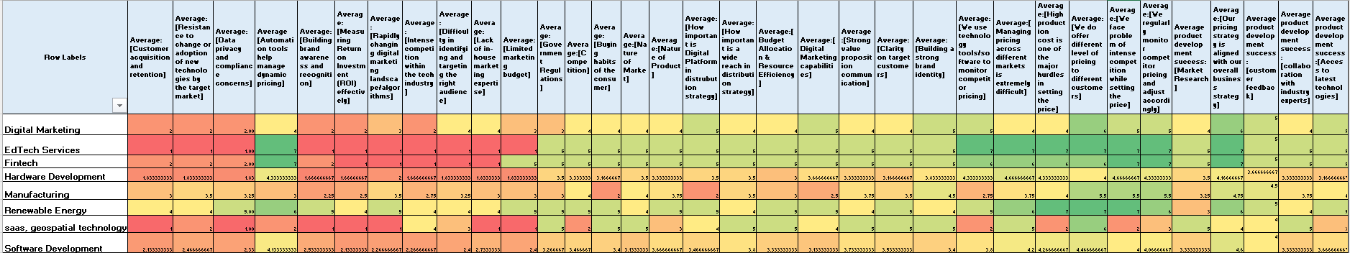
Key Insights
- High-Risk Clusters: The heatmap flags intense risk sectors across the Hardware Development and Manufacturing verticals. Hardware records a low average score of 1.83 for Customer Acquisition and 1.83 for Resistance to Technology Adoption. Manufacturing shows average scores of 3.0 and 3.5 respectively, confirming that physical tech sectors face a brutal operational environment characterized by long sales cycles and slow customer adoption.
- Software Dominance and Efficiency: Software Development presents a highly stable, uniform risk profile. It scores an optimized 4.26 for managing pricing strategies conforming that digital-only firms operate with a clear structural advantage in speed and efficiency.
- Fintech & EdTech Resource Constraints: Fintech and EdTech services show severe strain around compliance and security, scoring a low 2.00 for data privacy and regulatory management frameworks, including sectors like Digital marketing and Manufacturing also shows a low average rate for data privacy frameworks.
- Market Research Benchmark: Across all 8 sectors, 'Market Research Importance' scores a consistently high baseline average of 4.50+, proving that tech founders universally value upfront market validation, even when they lack the capital or tools to execute it effectively.
Conclusion

- The long-term viability of the technopreneurial ecosystem hinges upon a critical shift in product development paradigms, transitioning from early-stage qualitative intuition to structured operational discipline. The data reveals that while early-stage startups (<1 year) correctly prioritize customer-centric discovery, they operate with a severe framework deficit demonstrating an exclusive reliance on basic user feedback while neglecting structured management methodologies and quantitative data analytics. As ventures mature, the product development paradigm successfully evolves; software firms integrate structured management frameworks to stabilize their release cycles, while asset-heavy verticals like Hardware and Manufacturing return to sequential development roadmaps to mitigate fixed production costs and manage capital constraints.
- Most ventures fail to deploy quantitative data analytics telemetry, they rely too heavily on manual market research and the qualitative opinions of a few loud users. To mitigate these vulnerabilities, the ecosystem exhibits an overly cautious growth strategy, with majority of firms restricting their technological upgrades to iterative, single-feature "Product Improvement" rather than pursuing aggressive market expansion or true strategic diversification.
- Overall the data demonstrates that the Software Development sector follows the most successful and robust strategy within the entire enterprise ecosystem for several distinct operational reasons such as its Agile Framework Optimization, Pricing strategy and so on.

